**HTML5 Shooter Game Manual**

Manual Authored by: Chris Hamm

Game Coded by: Chris Hamm

6/20/2018

**Table of Contents**

1. Controls
2. Game Play
   1. General Description
   2. Player Weapon Descriptions
   3. HUD Description
   4. DEBUG Mode HUD Description
   5. DEBUG Mode Collision Lines Description
   6. Difficulty Levels
   7. Game Elements
      1. Meteors/Fast Meteors
      2. Enemy Ships
      3. Enemy Formation Ships
      4. Ammo Boxes
3. Cheat Codes
   1. List of Valid Cheat Codes
   2. How to input the Cheat Codes

**CONTROLS**

**Right Arrow Key:** Move player’s ship right

**Left Arrow Key:** Move player’s ship left

**‘E’ Key:** Pause/Unpause game

**‘F’ Key:** Toggle selected player’s weapon (Main Cannon/ Wing Cannon/ Tri Cannon)

**‘Spacebar’ Key:** Fire selected weapon

**‘Q’ Key:** Enable/Disable DEBUG Mode (Default Condition: DEBUG Mode is disabled)

**‘C’ Key:** Press while game is paused to enter in cheat code

**GAME PLAY**

**General Description**

The goal of this game is to survive as long as you can and to earn the highest score you can. Falling meteors, Enemy Ships, and Enemy Lasers are all capable of injuring the player’s ship. The player is given 3 lives at the start of the game. The only way to obtain more lives is to use the built in cheat codes. *NOTE: This game is designed to be run in a full screen browser window*

**Player Weapon Descriptions**

|  |  |  |  |  |
| --- | --- | --- | --- | --- |
| **Weapon Name** | **Weapon Image** | **Number of Lasers per Shot** | **Number of Shots Provided at Start of Game** | **Maximum Shot Capacity** |
| Main Cannon |  | 1 | 75 | 200 |
| Wing Cannons |  | 2 | 50 | 100 |
| Tri-Cannons |  | 3 | 25 | 50 |

**HUD Description**

**SCORE:** Indicates what the player’s current score is

**LIVES:** Indicates how many lives the player currently has

**DIFFICULTY LV:** Indicates what difficulty level the game is currently running at

**MAIN CANNON AMMO:** Indicates how much Main Cannon ammo the player currently has

**WING CANNON AMMO:** Indicates how much Wing Cannon ammo the player currently has

**TRI-CANNON AMMO:** Indicates how much Tri-Cannon ammo the player currently has

**OUT OF Main Cannon/Wing Cannon/Tri Cannon AMMO:** This message will display slightly above the player’s ship in dark red only when the player pressed the fire weapon key (spacebar) and there is no ammo of that type available.

**DEBUG Mode HUD Description**

**FrameNumber:** Indicates what frame the game is currently on

**Player_X:** Indicates what X coordinate the player’s ship is currently located at

**Player_Y:** Indicates what Y coordinate the player’s ship is currently located at

**# Enemy Ships:** Indicates how many enemy ships are stored in the enemyShips array

**# Formation Enemy Ships:** Indicates how many formation enemy ships are stored in the enemyFormationShips array

**DEBUG Mode Collision Lines Description**

When DEBUG Mode is enabled, orange lines will appear around the player’s ship. These lines represent where the collision detection occurs around the player’s ship. The extra parts of the lines that are not part of the box that directly surrounds the ship are not part of the collision detection.

**Difficulty Levels**

|  |  |  |  |  |  |  |
| --- | --- | --- | --- | --- | --- | --- |
| **Difficulty Level** | **Active Frames** | **Max Number of Enemy Ships (Non-Formation)** | **Spawn Rate for Enemy Ships** | **Spawn Rate for Formation Enemy Ships** | **Spawn Rate for Meteors** | **Spawn Rate for Fast Meteors** |
| 1 | Starts:  Frame 1  Ends:  Frame 2499 | 5 | Every 175 Frames | No Formation Ships Spawn | Min: Every 300 Frames  Max: Every 700 Frames | Min: Every 1000 Frames  Max: Every 2000 Frames |
| 2 | Starts:  Frame 2500  Ends:  Frame 3999 | 7 | Every 150 Frames | Min: Every 1000 Frames  Max: Every 3000 Frames | Min: Every 300 Frames  Max: Every 600 Frames | Min: Every 900 Frames  Max: Every 1750 Frames |
| 3 | Starts:  Frame 4000  Ends:  Frame 5999 | 10 | Every 125 Frames | Min: Every 800 Frames  Max: Every 1500 Frames | Min: Every 300 Frames  Max: Every 500 Frames | Min: Every 800 Frames  Max: Every 1500 Frames |
| 4 | Starts:  Frame 6000  Ends:  Frame 7999 | 15 | Every 100 Frames | Min: Every 600 Frames  Max: Every 1250 Frames | Min: Every 300 Frames  Max: Every 400 Frames | Min: Every 700 Frames  Max: Every 1250 Frames |
| 5 | Starts:  Frame 8000  Ends:  Frame 9999 | 18 | Every 75 Frames | Min: Every 400 Frames  Max: Every 1000 Frames | Min: Every 200 Frames  Max: Every 300 Frames | Min: Every 600 Frames  Max: Every 1000 Frames |
| 6 | Starts:  Frame 10000 | 21 | Every 60 Frames | Min: Every 300 Frames  Max: Every 750 Frames | Min: Every 125 Frames  Max: Every 200 Frames | Min: Every 500 Frames  Max: Every 750 Frames |

**Game Elements**

| **Element Name** | **Element Image** | **How They Spawn** | **How Often They Spawn** | **First Appears At Difficulty Level** |
| --- | --- | --- | --- | --- |
| Meteors |  | Automatically spawn after a certain period of time | At Difficulty 1:  Earliest: Every 300 frames  Latest: Every 700 frames  At Difficulty 2:  Earliest: Every 300 frames  Latest: Every 600 frames  At Difficulty 3:  Earliest: Every 300 frames  Latest: Every 500 frames  At Difficulty 4:  Earliest: Every 300 frames  Latest: Every 400 frames  At Difficulty 5:  Earliest: Every 200 frames  Latest: Every 300 frames  At Difficulty 6:  Earliest: Every 125 frames  Latest: Every 200 frames | 1 |
| Fast Meteors |  | Automatically spawn after a certain period of time | At Difficulty 1:  Earliest: Every 1000 frames  Latest: Every 2000 frames  At Difficulty 2:  Earliest: Every 900 frames  Latest: Every 1750 frames  At Difficulty 3:  Earliest: Every 800 frames  Latest: Every 1500 frames  At Difficulty 4:  Earliest: Every 700 frames  Latest: Every 1250 frames  At Difficulty 5:  Earliest: Every 600 frames  Latest: Every 1000 frames  At Difficulty 6:  Earliest: Every 500 frames  Latest: Every 750 frames | 1 |
| Enemy Ships |  | Automatically spawn after a certain period of time | At Difficulty 1: Every 175 frames (Max: 5 ships)  At Difficulty 2: Every 150 frames (Max: 7 ships)  At Difficulty 3: Every 125 frames (Max: 10 ships)  At Difficulty 4: Every 100 frames (Max: 15 ships)  At Difficulty 5: Every 75 frames (Max: 18 ships)  At Difficulty 6: Every 60 frames (Max: 21 ships) | 1 |
| Enemy Formation Ships |  | Automatically spawn after a certain period of time | At Difficulty 1: Doesn’t Spawn  At Difficulty 2:  Earliest: Every 1000 frames  Latest: Every 3000 frames  At Difficulty 3:  Earliest: Every 800 frames  Latest: Every 1500 frames  At Difficulty 4:  Earliest: Every 600 frames  Latest: Every 1250 frames  At Difficulty 5: Earliest: Every 400 frames  Latest: Every 1000 frames  At Difficulty 6: Earliest: Every 300 frames  Latest: Every 750 frames | 2 |
| Main Cannon  Ammo Box |  | Dropped by destroyed Enemy Ship or Enemy Formation Ship | 60% chance of being dropped* | 1 |
| Wing Cannon  Ammo Box |  | Dropped by destroyed Enemy Ship or Enemy Formation Ship | 30% chance of being dropped* | 1 |
| Tri Cannon  Ammo Box |  | Dropped by destroyed Enemy Ship or Enemy Formation Ship | 10% chance of being dropped* | 1 |

*An ammo box will always drop when an enemy ship or enemy formation ship is destroyed. What type of ammo box depends on a randomly generated number.

**CHEAT CODES**

**List of Valid Cheat Codes**

**ammo:** *(numbers that will appear at the bottom of the screen: 65777779)* Gives the player the maximum amount of every kind of ammo (main Cannon = 200, wing Cannon = 100, tri Cannon = 50)

**3up:** [using normal number key] *(numbers that will appear at the bottom of the screen: 518580)* Adds 3 lives to the player’s current number of lives.

**3up:** [using the number pad key] *(numbers that will appear at the bottom of the screen: 995880)* Adds 3 lives to the player’s current number of lives.

**How to Input the Cheat Codes**

First, pause the game by pressing the ‘E’ key.

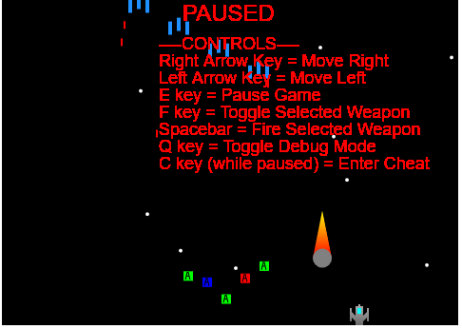

Second, press the ‘C’ key to bring up the cheat code prompt.

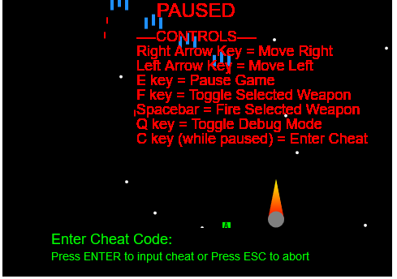

Third, enter in a valid cheat code (bold words listed above). Do not include the ‘:’ when entering the cheat code.

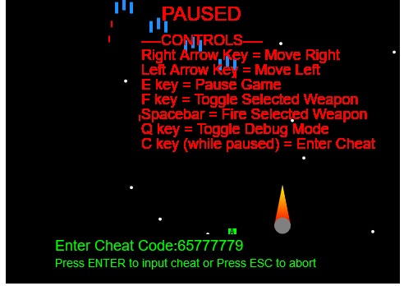

(Above) Example for ‘ammo’ cheat code

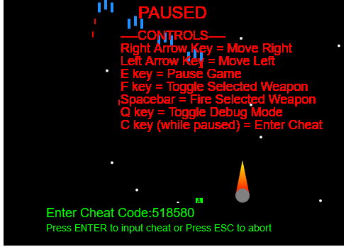

(Above) Example for ‘3up’ cheat code (using number keys)

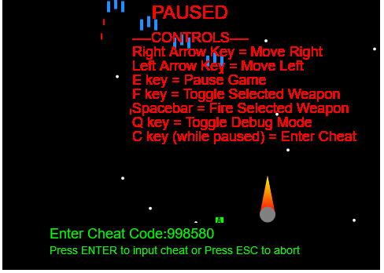

(Above) Example for ‘3up’ cheat code (using the number pad)

Finally, either press the ‘ENTER’ key to enter the cheat code or press the ‘Esc’ key to abort entering the cheat code. If the cheat code was invalid, it will display ‘Invalid Cheat Code Entered’.

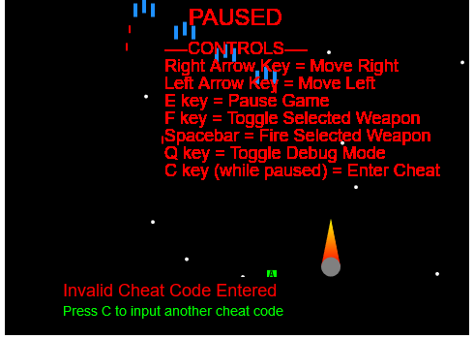

Example for invalid cheat code

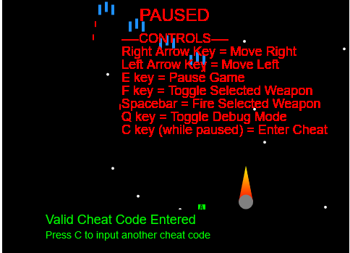

Example for a valid cheat code

If you want to enter in another cheat code, press the ‘C’ key again and then repeat the process.